CHANDIGARH UNIVERSITY

Project Report
on
“Coin Toss Game”


Submitted by: Harsimran Submitted to:Sunaiya Ma’am
UID: 25BCU10004 Subject: C Programming
Section: 25BCU-1(A) Subject Code-25CAH-101
Title: Coin Toss Game

Aim
To design and implement a simple Coin Toss Game using C programming that simulates a virtual coin flip and allows the user to guess the outcome.

Objectives

- To understand the use of random number generation in C.
- To implement conditional statements and loops.
- To enhance user interaction through console-based input/output.
- To develop a basic understanding of game logic and structure.

Introduction

The Coin Toss Game is a console-based application that mimics the flipping of a coin. The user is prompted to guess the outcome—Heads or Tails—and the program randomly generates the result. It then compares the user's guess with the actual result and displays whether the guess was correct. This project is ideal for beginners learning C programming, as it covers fundamental concepts like loops, conditionals, functions, and random number generation.

Methodology

- User Input: Prompt the user to choose between Heads or Tails.
- Random Generation: Use the rand() function to simulate a coin toss.
- Comparison Logic: Compare the user's guess with the generated result.
- Output Result: Display whether the user won or lost.
- Looping: Allow the user to play multiple rounds until they choose to exit.

Technology Used

- Programming Language: C
- Compiler: GCC (GNU Compiler Collection)
- IDE: Code::Blocks / Dev-C++ / Turbo C (any standard C IDE)

Hardware and Software Requirements

Components Specification
Processor Intel i3 or above
RAM 4GB minimum
Operating System Windows/Linux
Software C Compiler GCC/Turbo C),IDE

Source Code (C Language)

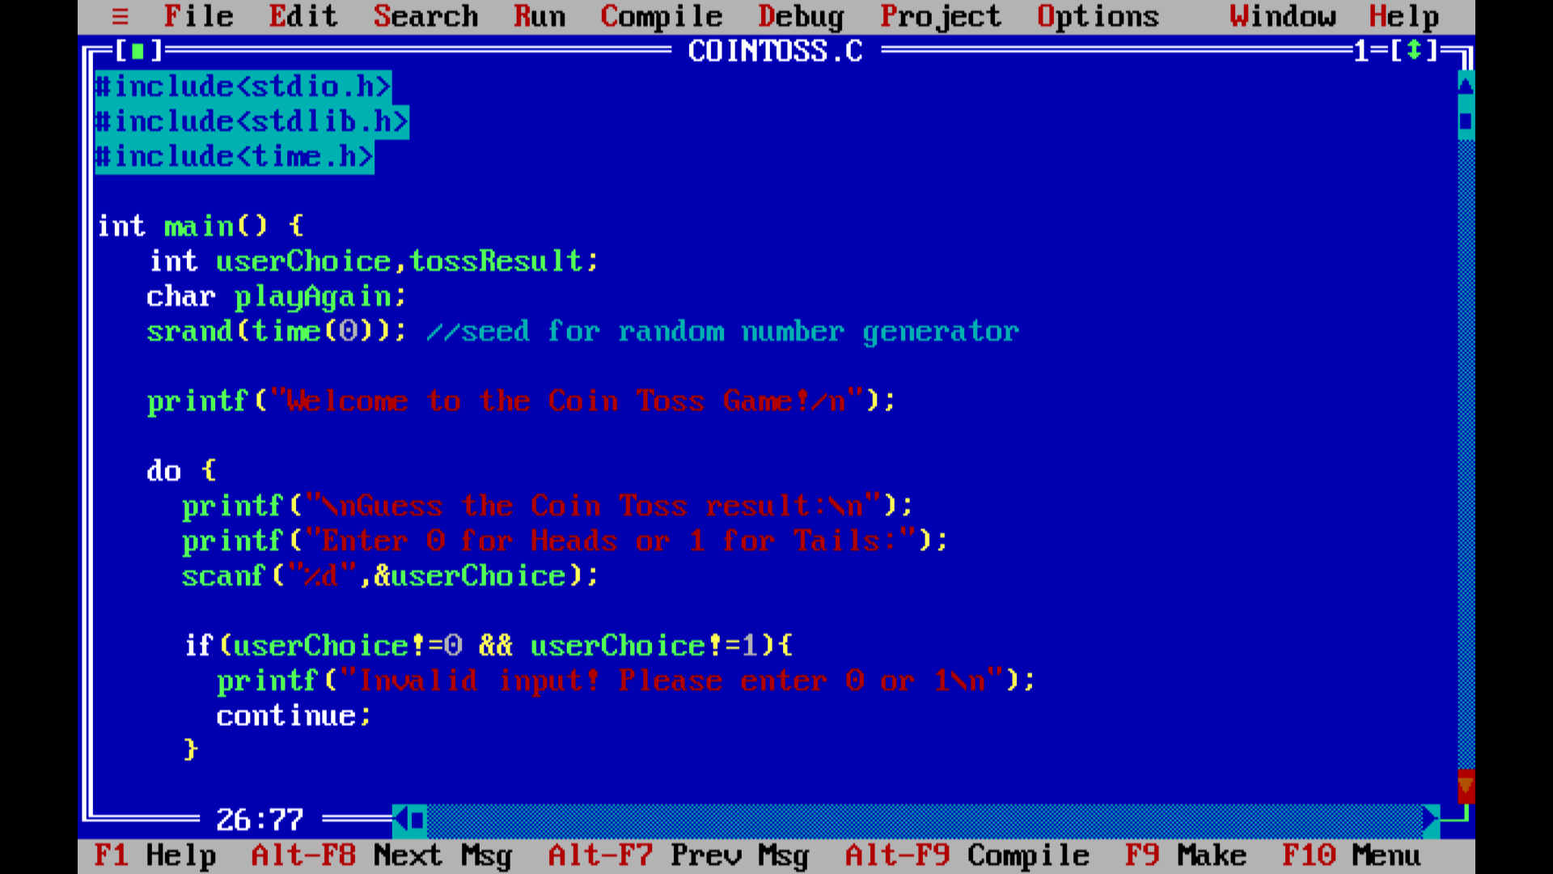

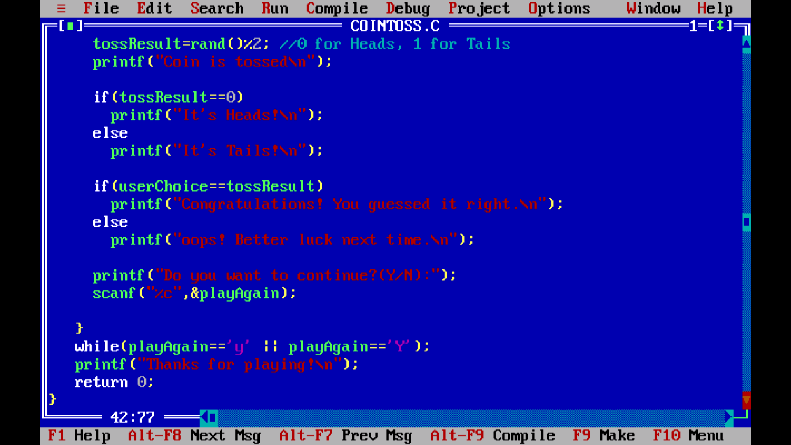

Sample Output

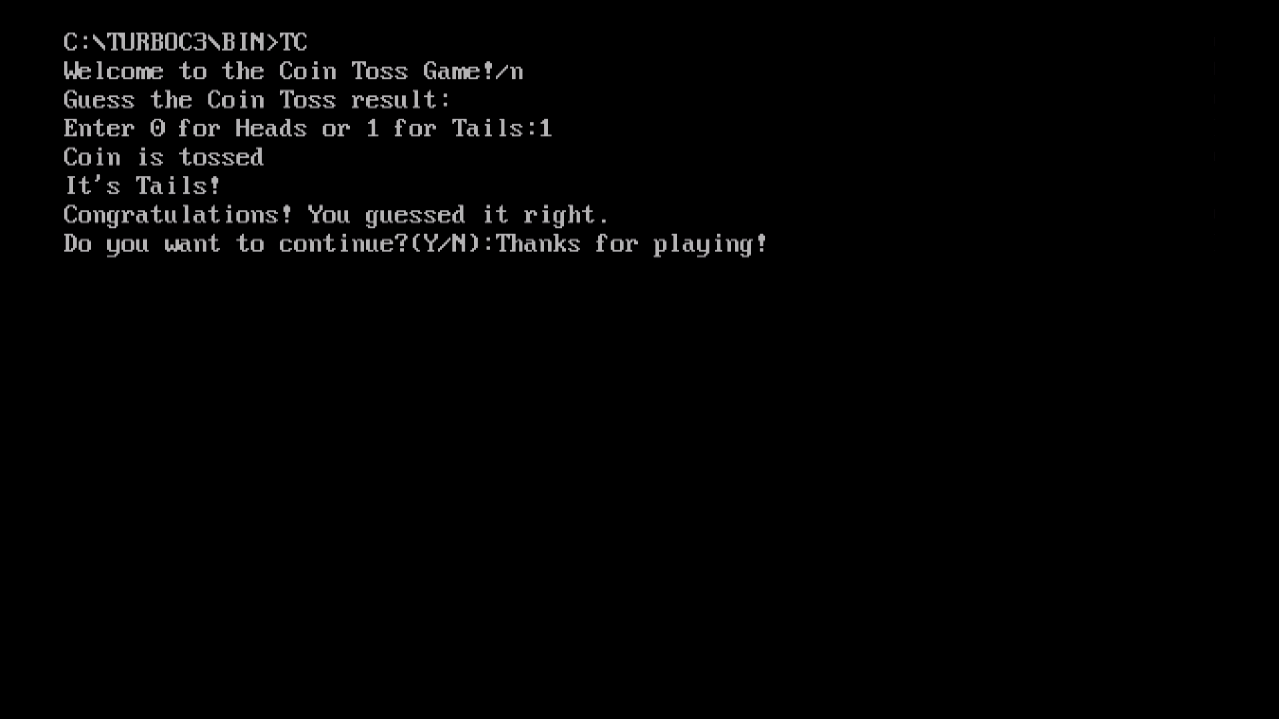

Conclusion

This project demonstrates how basic programming concepts in C can be used to create interactive applications. The Coin Toss Game is a simple yet effective way to practice user input handling, random number generation, and control structures. It also lays the foundation for more complex game development projects in the future.

